**Prototype Model :**

Definition: Prototyping is defined as the process of developing a working replication of a product or system that has to be engineered. It offers a small-scale facsimile of the end product and is used for obtaining customer feedback. The Prototyping concept is described below:

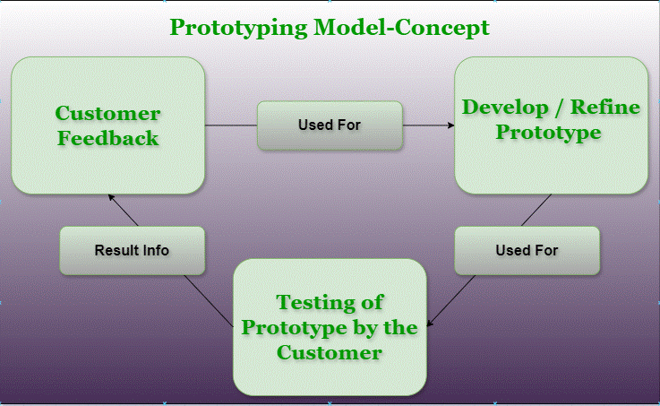

**Iteative model :**

In this Model, you can start with some of the software specifications and develop the first version of the software. After the first version if there is a need to change the software, then a new version of the software is created with a new iteration. Every release of the Iterative Model finishes in an exact and fixed period that is called iteration.

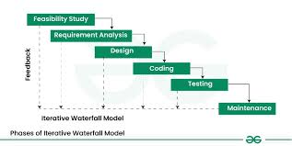

**Spiral Model :**

**The Spiral Model** is one of the most important [Software Development Life Cycle models](https://www.geeksforgeeks.org/top-8-software-development-models-used-in-industry/). The Spiral Model is a combination of the waterfall model and the iterative model. It provides support for **Risk Handling**.

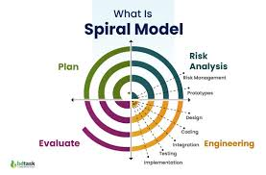

**Rapid Applications :**

The Rapid Application Development Model was first proposed by IBM in the 1980s. The RAD model is a type of incremental process model in which there is an extremely short development cycle. When the requirements are fully understood and the component-based construction approach is adopted then the RAD model is used. Various phases in RAD are [Requirements Gathering](https://www.geeksforgeeks.org/requirements-gathering-introduction-processes-benefits-and-tools/), [Analysis](https://www.geeksforgeeks.org/activities-involved-in-software-requirement-analysis/) and Planning, Design, Build or Construction, and finally Deployment.

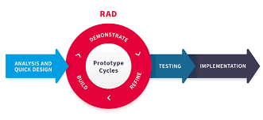

**Development Model :**

Software development models provide the framework used to plan and execute software milestones and delivery cycles throughout the life of an application. While each design and development model has a different emphasis, they all follow the same basic flow of researching the requirements, design, implementation (coding), and verification or testing. The main difference is in the implementation of these phases

